Spring 2023 I Student News
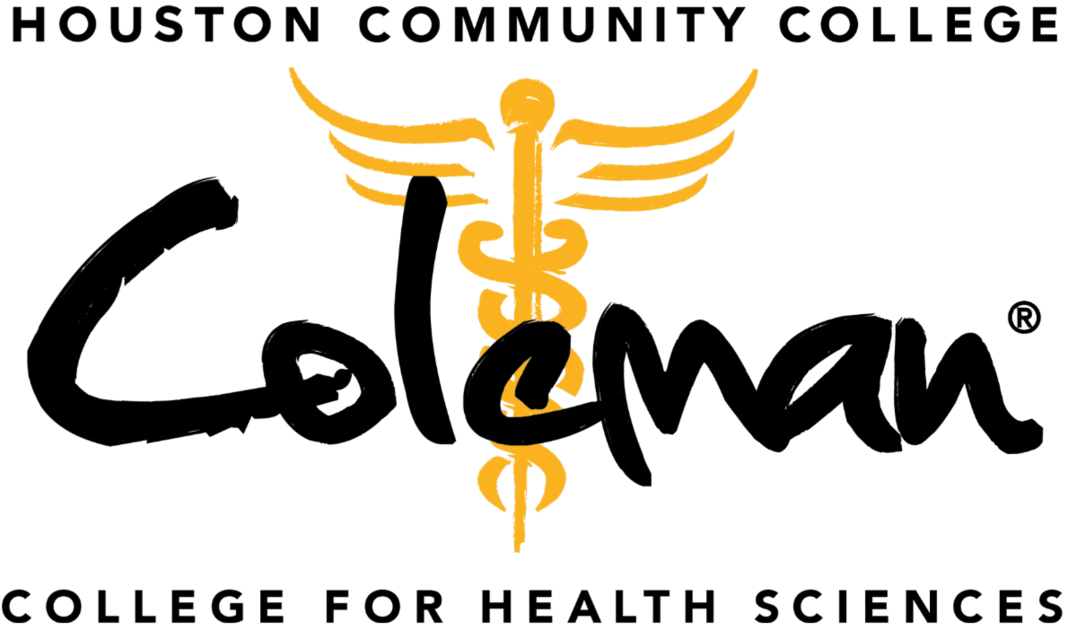

Class of 2023 Pinning Ceremonies
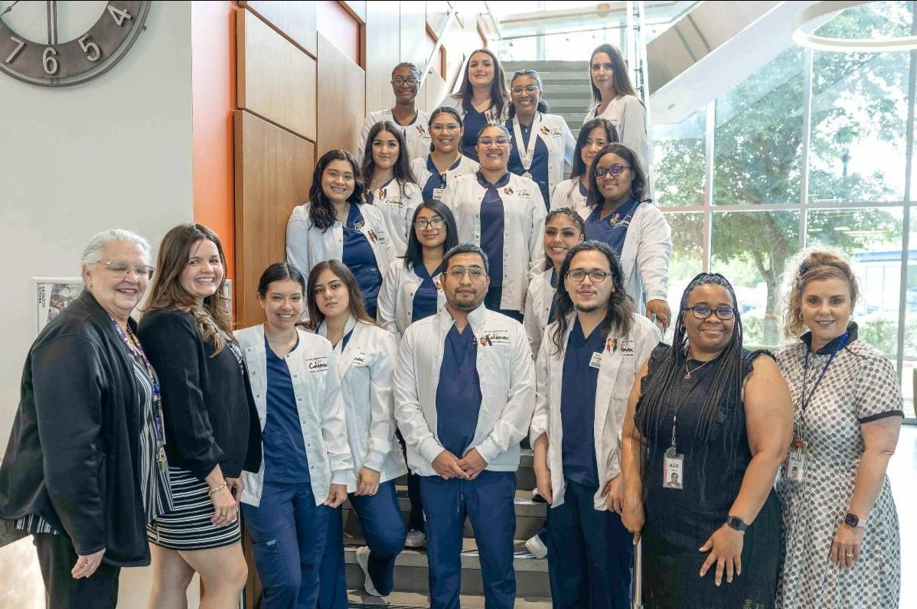
Medical Assistant
Twenty Medical Assistant graduates received their pin at the pinning ceremony on April 21 at Coleman Tower Atrium.
See the photos!

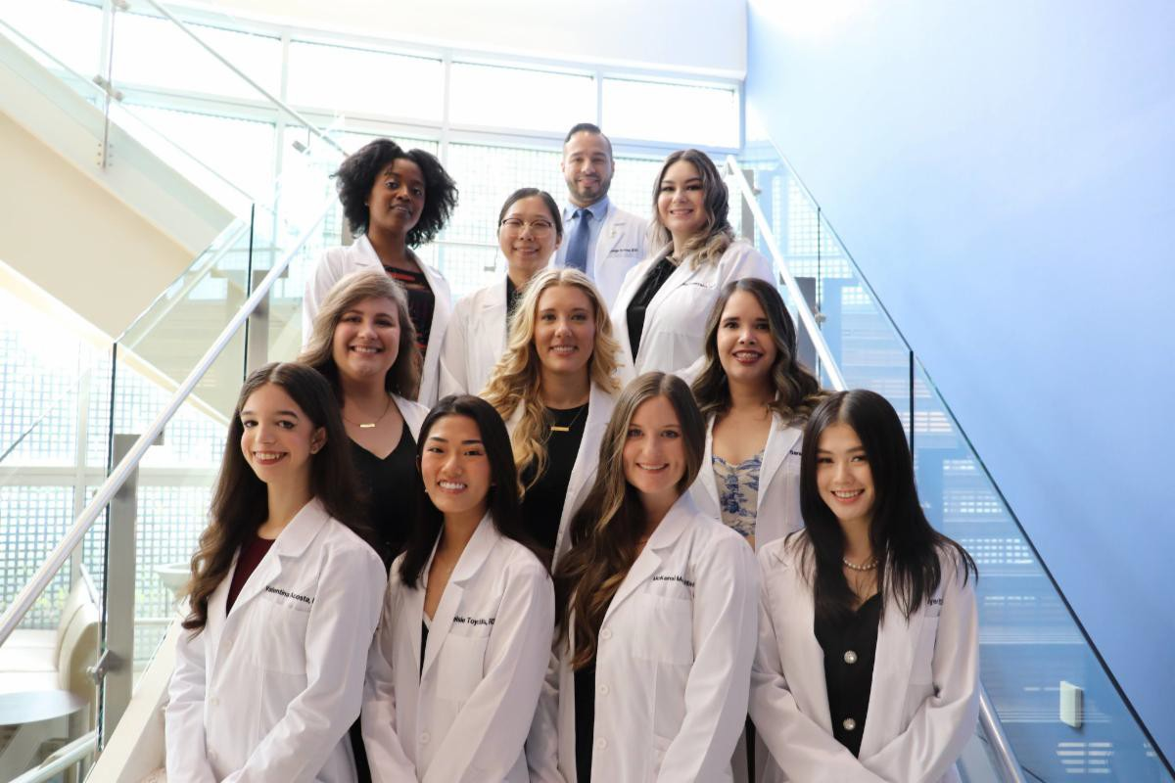
Dental Hygiene
Eleven Dental Hygiene graduates received their pin at the pinning ceremony on May 6 at Coleman Auditorium.
See the photos!

Physical Therapist Assistant
Twenty-nine Physical Therapist Assistant graduates received their
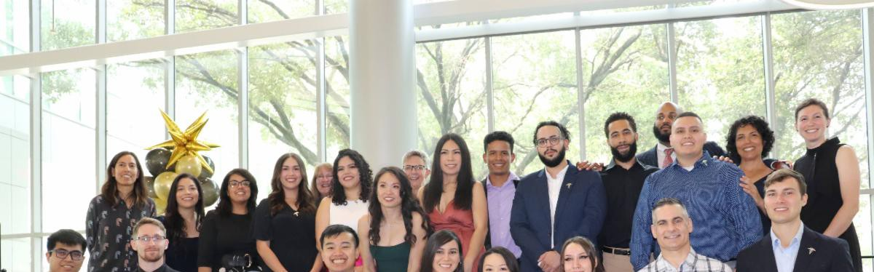
pin at the pinning ceremony on May 6 at Coleman Tower Atrium.
See the photos!

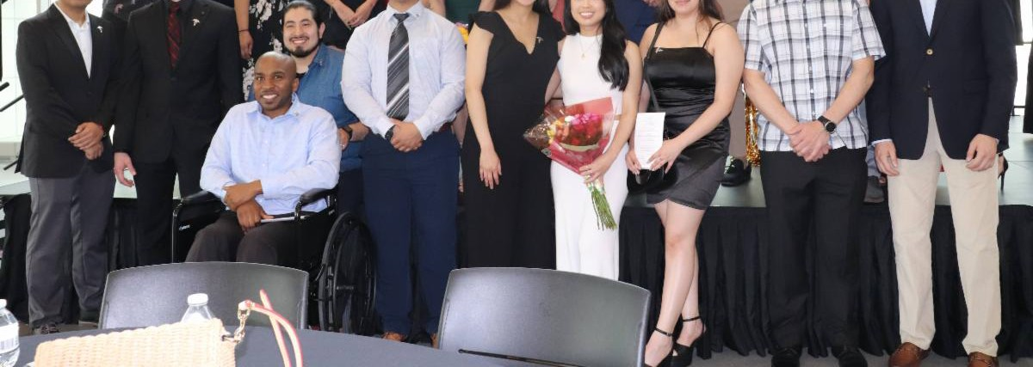

Occupational Therapy Assistant
Twenty-seven Occupational Therapy Assistant graduates received their pin at the pinning ceremony on May 6 at Coleman Tower Atrium.
See the photos!

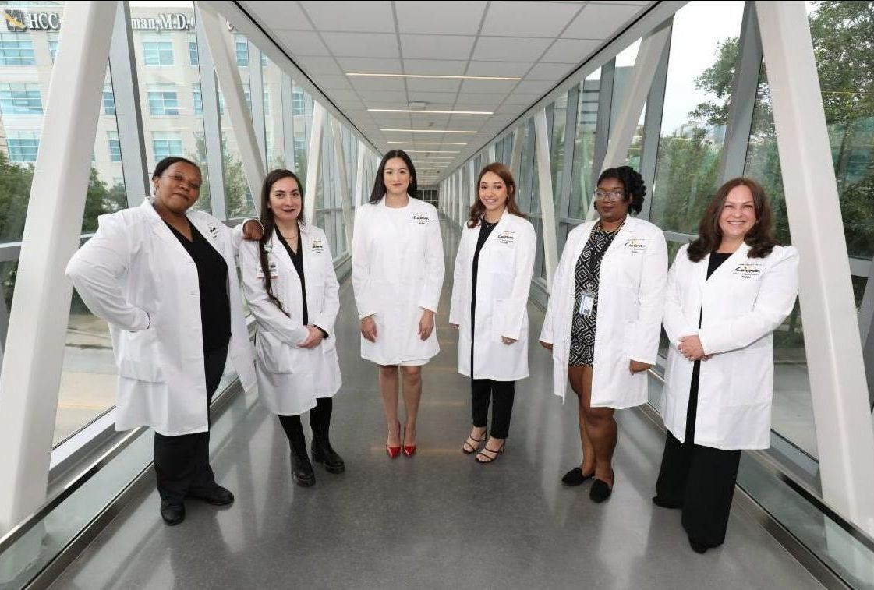
Endoscopy Technician
Six Endoscopy Technician graduates received their pin at the pinning ceremony on May 9 at Coleman Tower Atrium.
See the photos!

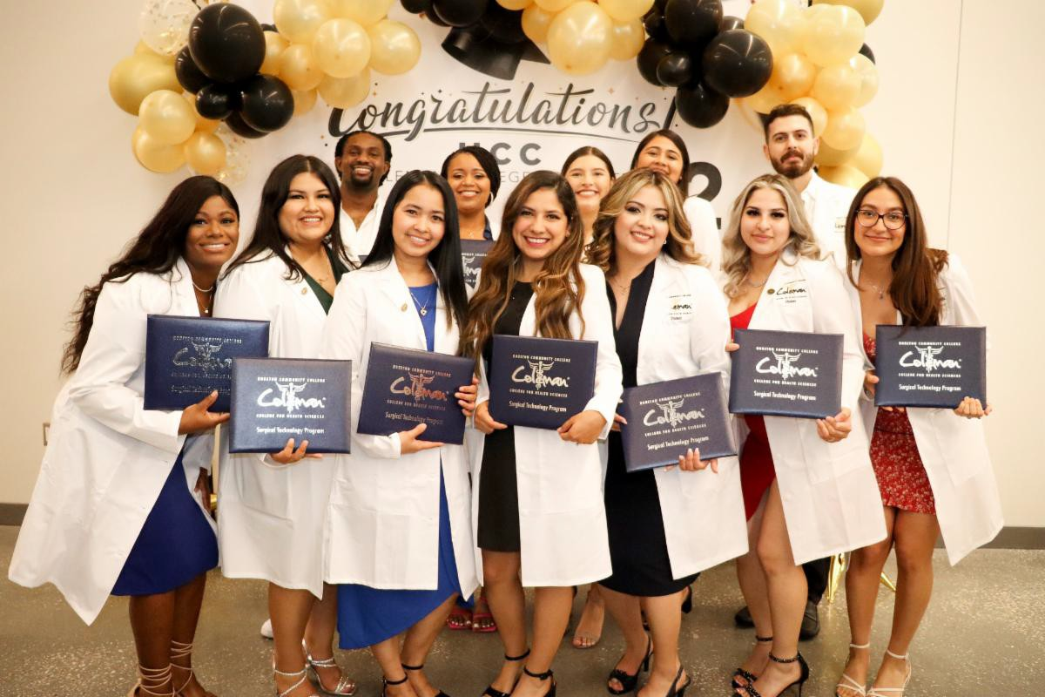
Surgical Technology
Twelve Surgical Technology graduates received their pin at the pinning ceremony on May 9 at Coleman Tower Atrium.
See the photos!

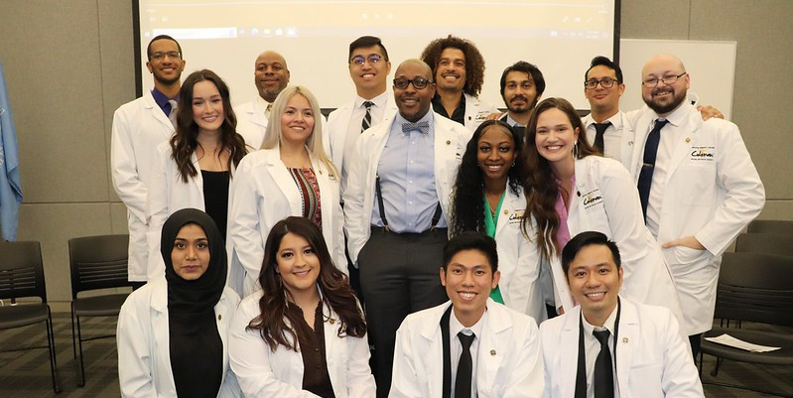
Nuclear Medicine
Sixteen Nuclear Medicine graduates received their pin at the pinning ceremony on May 11 at Coleman Auditorium.

See the photos!

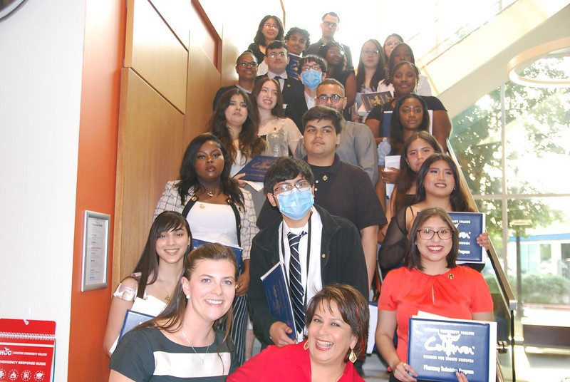
Pharmacy Technician
Twenty-six Pharmacy Technician and dual credit graduates received their pin or certificate on May 11 at Coleman Tower Atrium.
See the photos!

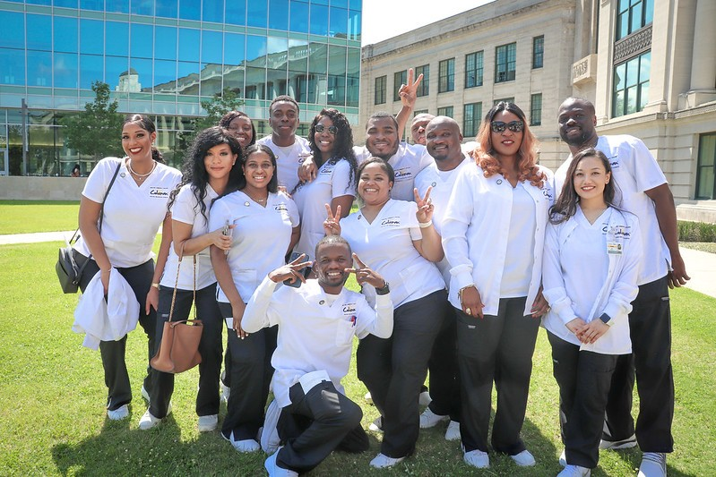
Associate Degree Nursing
Eighty Associate Degree Nursing graduates received their pin at the pinning ceremony on May 16 at HCC Central Auditorium.
See the photos!

Soaring Students

Coleman Champion: Giovanna Sosa
Read her profile!
Read her story!
Read her profile!
Maren Jensen receives NSLS scholarship
Coleman Colleague: Emma Wood, 2021

Do you have some Eagle news to share?
Email Coleman Communications!

HCC Coleman College | 1900 Pressler St., Houston, TX 77030

Unsubscribe farah.togle@hccs.edu Update Profile |Constant Contact Data Notice
Sent byco.communications@hccs.eduin collaboration with
Try email marketing for free today!

