Alternative Teacher Certification Program Handbook
Southeast College | Eastside Campus Felix Morales Building, Rm 126 and 101
6815 Rustic,
Houston, TX 77087
(713) 718-8149
Email: atcp@hccs.edu

ATCP Handbook 2022-2023 Updated 10/2022

Table of Contents

Section I Program Admissions Process 1
Entrance Requirements 1
TOEFL Exemption 1
TOEFL Conditional Exception 2
Pre-Admissions Content Test (PACT) (TX PACT) 2
About Pre-Admission Content Test (PACT) (TX PACT) 2
Score Reporting 2
Transfer Students 3
Program Admissions Process 3
Step 1: Apply 3
Step 2: Evaluation 3
Step 3: Haberman Survey 4
Step 4: Acceptance 4
Step 5: Begin Training 4
Section II Learning Formats for Program 5
Face to Face 5
Section III Coursework and Field-based Experiences 6
Coursework 6
ACP 4103 (formerly ACP 1000) Cognitive Development, Literacy Strategies and Special Education 8
ACP 4113 Content Preparation 8
ACP 4203 (formerly ACP 2000) Pedagogy for Curriculum and Instruction 8
ACP 4201 Pre-Service Field-based Observation (30 hours) 8
ACP 4213 Science of Teaching Reading (STR) 9
ACP 4303 (formerly ACP 3000) Managing Culturally Diverse Classrooms 9
ATCP 4403 (formerly ACP 4000) Professional Practices in an Educational Environment 9
ACP 5006 Foundations of Reading 9
ACP 5007 Teaching Second Language Learners 9
ATCP 4513 Internship I 10
ATCP 4523 Internship II 10
Program ePortfolio 11
Field-based Experiences 11
Statement of Eligibility 11
Steps to Apply for Internship 12
Field Supervision 19
Testing 19
Certifications Offered 20
Section IV Program Policies and Procedures 22
Policy for State Certification Testing 22
Academic Standing 22
Students in Good Standing 22
Students on Probation 22
Student (Educator Candidates) Dismissal 22
Transfers and Withdrawals 23
Pre-Intern and Intern Records 24
Changing Certification Area 24
Student Code of Conduct 24
Section V Student Services and System Policies 25
Student Services 25
Bookstore 25
Parking Passes 25
HCC Policies 26
EGLS3 26
Campus Carry Link 26
HCC Email Policy 26
Housing and Food Assistance for Students 26
Office of Institutional Equity 27
Ability Services 27
Title IX 27
Office of the Dean of Students 27
Veteran Services 27
Career and Job Placement 28
HCC CareerHub 28
Student Identification Card 28
Student picture ID 29
Polices Services and Campus Safety 29
Additional Program & College Policies 30
Class Attendance 30
Religious Holidays 30
Personal Property 30
Eating and Drinking in Classrooms 30
Dress Code 30
Children 30
Smoking 30
Drug and Alcohol-Free Workplace 30
Student Code of Conduct 31
Scholastic Dishonesty 31
Misuse of Electronic Devices in the Classroom 31
The Family Educational Rights & Privacy Act (FERPA) 31
Annual FERPA Notification 31
Refund Policy 33
Refund Policy 33
Section VI Financial Aid and Tuition & Fees 34
Financial Aid Assistance 34
Program Tuition and Fees 34
Program Glossary 35
Policies and Procedures Acknowledgement Form 38
Appendix 39

Overview
The Alternative Teacher Certification Program at Houston Community College is a state-approved comprehensive educator preparation program that trains individuals for the Texas standard certification in elementary and secondary education.

Alternative Teacher Certification Program (ATCP) Mission
The mission of the Houston Community College Alternative Teacher Certification Program (ATCP) is to provide aspiring educators with a quality education that equips program participants with the skills, competencies, knowledge, and cultural responsiveness necessary to provide effective student-centered classroom instruction to the twenty- first-century learner.

Alternative Teacher Certification Program (ATCP) Vision
ATCP will transform K-12 Education by training, coaching, and mentoring highly qualified, effective classroom teachers to provide rigorous, data-driven, best practice instruction that will accommodate the needs of the twenty-first-century learner.

Section I
Program Admissions Process

Entrance Requirements

- Hold a bachelor's degree from a regionally accredited institution of higher education. A bachelor's degree must be earned and conferred by an institution of higher education that is recognized by one of the regional accrediting agencies by the Texas Higher Education Coordinating Board (THECB). Check with your institution for accreditation status.

If you have an undergraduate or graduate degree from a university or college outside of the United States, your international transcripts must be evaluated by a foreign credential evaluation service. (See page 10 for the details.)

- Must have a minimum cumulative grade point average (GPA) of 2.50 or at least a 2.50 in the last 60 semester credit hours. If you earned a master’s degree or higher, then the program will consider the GPA from your advanced degree.

Submit official transcripts from every college or university you attended to determine your GPA.

Demonstrate content mastery in the content area for the certification sought by the applicant by meeting the prerequisite coursework requirements from the applicant's transcript or by submitting a passing score on the content examination through the TX PACT (Pre-Admission Content Test).

The TX PACT is an alternative option for applicants that do not meet the program's GPA requirement. Applicants that seek this option must not be affiliated, or had prior enrollment, with another alternative teacher certification program. More information about the TX PACT is detailed below in the packet.

Must demonstrate oral communication skills In the English language.

If you hold an undergraduate or graduate degree outside of the United States, you may have to take the TOEFL iBT exam https://www.ets.org/toefl. The TOEFL exam measures your ability to use and understand English at the university level. It evaluates how well you combine your listening, reading, speaking and writing skills. The state of Texas mandates that an applicant for a Texas educator certificate must take the TOEFL exam and submit the following required scores:

- Speaking 24
- Listening 22
- Reading 22
- Writing 21

TOEFL Exemption:

- If you completed at least an undergraduate or graduate degree at a regionally accredited institution of higher education in the United States.
- If you earned an undergraduate or graduate degree from an institution of higher education outside of the United States located in a country where English is the official language of the country.
- The State Board for Educator Certification (SBEC) of Texas has a list of approved countries located in 19 TAC§230.11(b)(5)(B) https://tea.texas.gov/sites/default/files/19-230-0011-1.pdf

Pre-Admissions Content Test

About Pre-Admission Content Test (PACT) (TX PACT)

A Pre-Admission Content Test (PACT) (TX PACT) can be used for consideration of admission to an alternative certification or post-baccalaureate educator preparation program (EPP).

TEA requires applicants to take and pass a PACT (TX PACT) for admission into an EPP in the following cases:

1. If the applicant has a GPA below a 2.5 or
2. If the applicant has not completed at least 12 semester credit hours in the subject area of the
certificate the applicant is seeking (15 hours if seeking certification in math or science above 7th
Grade).

PACT (TX PACT) is not required for applicants who meet the 2.5 GPA and have completed a minimum of either 12 or 15 semester credit hours of coursework. Educator preparation programs may have local policies that require applicants to pass a PACT (TX PACT) as a requirement for admission, but those policies are local decisions.

About Pre-Admission Content Test (PACT) (TX PACT)
Please note, candidates who need to take a PACT (TX PACT) exam for the following areas should take PACT (TX PACT): Essential Academic Skills (700) (e.g., Core Subjects: Early Childhood–Grade 6; Deaf and Hard of Hearing: Early Childhood–Grade 12; Special Education: Early Childhood–Grade 12). For more information about which PACT (TX PACT) exam is associated with each Texas Certificate, see the Pre-Admission Content Test page on the Texas Education Agency website at the following link: https://tea.texas.gov/texas-educators/certification/educator-testing/pre-admission-content-test

Score Reporting
Paper reports are not sent to test takers. PACT (TX PACT) test takers can view their score reports through their testing accounts on the Pearson website. If the result status is "Not Passed", you must wait 45 days between each test type to retest. Educational Preparation Program (ATCP) does not receive your scores automatically. You may submit your score report to atcp@hccs.edu for possible admissions into the HCC's Alternative Teacher Certification Program.

Transfer Students

Applicants seeking admission into the Houston Community College Alternative Teacher Certification Program that is transferring from another alternative teacher certification program must submit their TEA Candidate Transfer Form from the releasing EPP to be considered for admission. Transfer applicants must pay the full cost of tuition and fees for the program. Applicant’s transcripts will be evaluated on an individual basis. Transferring EPP hours/credits are subject to review.

Program Admissions Process
Step 1: Apply
  - Submit the “Continuing Education” application online to enroll in the college by selecting this link: https://hccapp.hccs.edu:9200/psc/adm/EMPLOYEE/SA/c/HCC_CUSTOM_MENU_FL.HAD_STARTNW_FL.GBL
After opening the above link, select “Continuing Education” and complete the online application. This will provide you with an HCC Student ID # if you are a first-time applicant. Please make note of your student ID #. NOTE: If you previously enrolled at Houston Community College, you will need to contact the ATCP office to have the ATCP application added to your HCC Student Profile. The application will appear in the “Other Checklist” once it has been added.

Submit Official Transcripts
To determine your eligibility for the teacher certification program, please submit an official transcript from all colleges or universities you previously attended. Please save your official transcript as a PDF entitled, "02_Official Transcript_YourLastName, YourFirstName" and email your saved PDF application to atcp@hccs.edu. The subject of your email should be the name of your saved file detailed in the above quotations unless it is included with your application packet. Please do not include the quotations when you save the document or in your email's subject line.

Provide receipt of $75 application fee (non-refundable)
All program application fees must be paid at the HCC Southeast Campus’ business office. Contact the business office by phone (713-718-7051) or email (sebusinesscashier@hccs.edu) to make your payment. Once you pay your application fee, please save your application receipt as a PDF entitled, "03_Application Receipt_YourLastName, YourFirstName" and email your saved PDF application to atcp@hccs.edu. The subject of your email should be the name of your saved file detailed in the above quotations unless it is included with your application packet. Please do not include the quotations when you save the document in your email's subject line.

Apply for financial aid/or scholarships (optional)
Federal financial aid is not applicable to alternative teacher certification programs. However, there are other options provided for certain certification areas through state initiatives. Eligibility does not automatically guarantee candidates receive funding.

Provide PACT (TX PACT) Score Report(s) (If applicable)
Please save your PACT (TX PACT) score as a PDF entitled, "04_TX PACT Scores_YourLastName, YourFirstName" and email your saved PDF application to atcp@hccs.edu. The subject of your email should be the name of your saved file detailed in the above quotations unless it is included with your application packet. Please do not include the quotations when you save the document or in your email's subject line

Provide TOEFL Exam Score Report (If applicable)
Please save your TOEFL score as a PDF entitled, "05_TOEFL Scores_YourLastName, YourFirstName" and email your saved PDF application to atcp@hccs.edu. The subject of your email should be the name of your saved file detailed in the above quotations unless it is included with your application packet. Please do not include the quotations when you save the document or in your email subject line.
Please email the above documents to atcp@hccs.edu.

Step 2: Evaluation

Staff evaluates transcripts and reviews submitted documentation
Please allow 5–7 business days for processing. Incomplete applications may delay the process. To check the status of the application, please call 713-718-8149 or email atcps@hccs.edu.

Step 3: Haberman Teacher Pre-Screener

Candidates will be sent the Haberman Teacher Pre-Screener to the email provided. The Pre-Screener will be sent in a separate email from the Haberman Foundation. Candidates must complete the Pre-Screener within 2 days.

Step 4: Acceptance

Receive and return program acceptance letter
Receive a formal acceptance letter via email, sign the document with an electronic signature, and return your signed acceptance letter verifying your intent to enroll in the program via email at atcp@hccs.edu.

Step 5: Begin Training

Attend the new student orientation
Attendance to the new student orientation for the ATCP is mandatory. At the end of the orientation, you must sign the program’s Educator Candidate Handbook located on the last page of the document in order to enroll in the program. This signature verifies that you agree to abide by all policies, procedures, and requirements of Houston Community College in addition to the policies, procedures, and requirements of the ATCP.

Secure payment for tuition/fees
Students can arrange a payment plan to cover the cost of tuition and fees for the program. Candidates must pay the ACP tuition in full by beginning of semester or first day of class unless the candidate arranged a payment with the HCC Southeast Campus Business Office. If you are interested in this option, please contact the HCC Southeast Campus’ Business Office by phone (713-718-7051) or email (sebusinesscashier@hccs.edu) to make this arrangement. Otherwise, candidates can log on to hccs.edu/student system or https://myeagle.hccs.edu/ to pay the full tuition and fees online to avoid the trouble of waiting in line to pay in person on campus.

Learning Formats for Program
The Houston Community College (HCC) Alternative Teacher Certification Program (ATCP) is a face-to-face program (in-person).

Face to Face

Educator candidates during this learning format meet with their instructors and classmates’ in-person at the HCC Southeast campus. As of late, there are no program offerings at the other HCC campuses. The meeting location varies each semester and the meeting space varies from different classrooms located at the HCC Southeast campus. Candidates will receive notification of their meeting location during the mandatory program orientation. This format, if chosen by candidates, allows for the personal interactions with candidates’ course instructors. Candidates should know that there may be meetings in which candidates must meet in-person for the co-requisite courses. The schedule for these meeting days are provided to candidates at the onset of the semester. In-person meetings for the co-requisite courses will usually occur during the weekend to accommodate those candidates with obligations during the workweek.
Instructors will notify all candidates of meeting either synchronously/asynchronously at their discretion.

Section III

Coursework and Field-based Experiences

Coursework

Educator candidates must complete a minimum of 300 clock hours of instruction as designated by the Texas Administrative Code. There are four primary courses for the program: (1) Cognitive Development, Literacy Strategies and Special Education (ACP 4103); (2) Pedagogy for Curriculum and Instruction (ACP 4203); (3) Managing Culturally Diverse Classrooms (ACP 4303); and (4) Professional Practices in an Educational Environment (ACP 4403). The aforementioned courses are 48 hours each. The additionally required courses, the Science of Teaching Reading (ACP 4213), Specific Content Preparation (ACP 4113), and Pre-Service Field Observations (ACP 4201) are of varying length in duration and may be taken simultaneously with ACP 4103 to ACP 4403 as advised.

The course schedule for candidates to complete the program within 12 to 18 months requires that candidates complete the four courses during the first semester, and the remaining courses during their second semester. This schedule applies to candidates that enroll in any alternative certification program for the first-time. The course schedule for transfers or returning candidates may vary. Candidates must select the course schedule sequence located in the appendix and return it to the ATCP Program office in addition to uploading the document to candidates’ E-Portfolio.

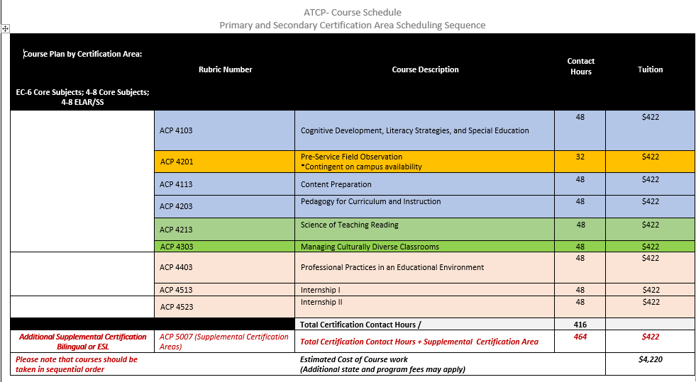

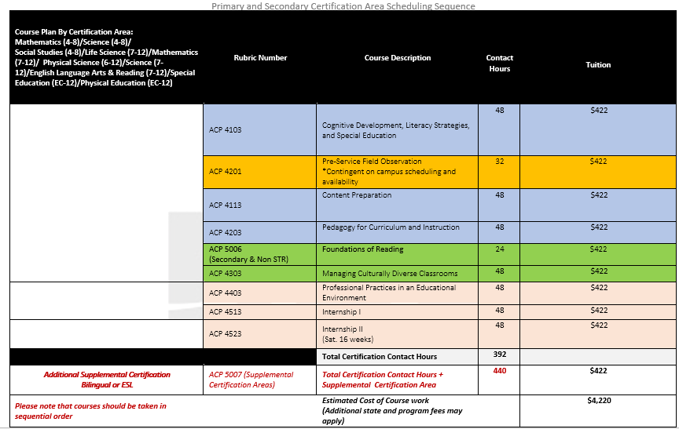

ACP 4103 (formerly ACP 1000)
Cognitive Development, Literacy Strategies and Special Education

Educator candidates learn the foundation of primary and secondary education in addition to study major developmental learning theories and contexts of the construction of these theories coupled with the implications for teaching, learning, and the classroom environment. Additionally, participants study literacy, reading and fluency, information processing, the response to intervention (RTI) process, and the role of special education in school.

ACP 4113

Content Preparation

Educator candidates undergo rigorous preparation for the state content examination. Educator candidates engage in independent and guided practice in the content area in which they must demonstrate mastery of their certification area.

ACP 4203 (formerly ACP 2000)

Pedagogy for Curriculum and Instruction

Educator candidates explore the foundations of lesson planning and lesson plan formats, and how they influence instructional delivery. Additionally, educator candidates examine types of assessments along with when and how assessments are used. Educator candidates explore the interrelationships among English as a Second Language (ESL) students reading processes and language learning applied across subjects. Course content includes foundation and skills, graphic organizers, the use of strategies for active engagement, reading comprehension, metacognition, text structure, inferencing, comparing and contrasting, analyzing a text, and inquiry-based instruction.

ACP 4201
Pre-Service Field-based Observation (30 hours)

The Texas Education Agency (TEA) requires that all educator candidates complete 30 hours of pre-service field observations. Fifteen of the 30 clock-hours for field-based observations may be completed virtually by observing pre-recorded videos. The remaining 15 clock-hours must occur in-person.

When performing all field-base observations, either virtually or in-person, candidates must actively observe and document the following:

- authentic school settings in a public school accredited by the TEA or other school approved by the TEA for this purpose such as a charter school;
- instruction conducted by content certified teachers;
- actual students in classrooms/instructional settings with identity-proof provisions;
- content or grade-level specific classrooms/instructional settings

ACP 4213

Science of Teaching Reading (STR)

Educator candidates will undergo rigorous preparation for the state examination, the Science of Teaching Reading. Educator candidates will focus on research-based strategies used in elementary and middle-grade classrooms designed to increase their knowledge and implementation of evidence-based practices that positively impact literacy achievement.
The Science of Teaching Reading state examination is only required for the following certification areas: Core Subjects EC-6; Core Subjects 4-8; and ELAR/Social Studies 4-8.

ACP 4303 (formerly ACP 3000)

Managing Culturally Diverse Classrooms

Educator candidates’ focus on research-based strategies in elementary and secondary classrooms designed to create a positive instructional environment for diverse learners. Strategies used to promote the organization and management of classrooms, the centrality of diversity in K-12 schools, the response to disruptive behaviors, and the improvement of instruction are included.

ATCP 4403 (formerly ACP 4000)

Professional Practices in an Educational Environment

Educator candidates focus on preparing teacher candidates to enhance professional learning communities while demonstrating leadership with students, colleagues, and community members in the school, the district, and the community through effective communication and outreach.

ACP 5006
Foundations of Reading

This course is designed for students in the alternative certification program seeking initial teacher certification. The focus is on the reading process and the factors that affect its development. The importance of reading in school and in life serves as a background for critical evaluation of the methods and materials of reading instruction. Special consideration is given to the essential components of research-based strategies and the features of classrooms that support effective reading instruction, and content area literacy. Instruction will focus on a balanced approach to reading that supports the needs of diverse learners.

ACP 5007
Teaching Second Language Learners

The material covered in this course is designed to prepare knowledgeable and effective educator candidates in theory and pedagogical skills for second language learners in K-12 grades. This course directly aligns with the course outcomes and objectives set by the Texas legislator.

ATCP 4513
Internship I

All candidates that received a teacher eligibility form are eligible for this course. During this course, candidates are either seeking employment or employed by a TEA accredited school.

Eligibility requires that candidates pass their initial content examination and have completed a minimum of 150 course hours and which include the following classes: (Refer to the course layout that has a list of courses and suggested benchmarks).
- ACP 4201
- ACP 4103
- ACP 4113
- ACP 4203
- ACP 4213
- ACP 4303

ATCP 4523
Internship II
All candidates that received a teacher eligibility form are eligible for this course. During this course, candidates are either seeking employment or employed by a TEA accredited school.

Eligibility requires that candidates pass their initial content examination and have completed a minimum of 150 course hours and which include the following classes: (Refer to the course layout that has a list of courses and suggested benchmarks).
- ACP 4201
- ACP 4103
- ACP 4113
- ACP 4203
- ACP 4213
- ACP 4303

Program E-Portfolio

Educator candidates will create an E-Portfolio that will be used throughout the program. The purpose of the E-Portfolio is to record a student’s learning by collecting work (evidence) in an electronic format over the course of their academic career. The E-Portfolio will be shared with your instructor and program personnel during the course of the program. The E-Portfolio will allow for both student and faculty to learn about the achievement of important outcomes, connections made with the curriculum, and gain insights leading to improvement. Please access the following link to view the instructions for creating an E-Portfolio: https://edutube.hccs.edu/media/t/1_t55j74le .

The building of a strong E-Portfolio will consist of key artifacts that will enable you to use well beyond the program as you enter the professional world of education. The following are examples of the essential components of the E-Portfolio.

- Education Philosophy
- Résumé (Educational Background/Professional Experience)
- Evidence of Competencies
- Evidence of State Examination Score
- Presentations, Documents, Videos, and Coursework
- Thirty Hours of Field-based Observations
- ATCP Program Checklist (continue to update E-Portfolio as tasks are completed)

Field-based Experiences

30-hours of Field Observations

Educator candidates will be required to complete 30 hours of field observation. The state requirement must be completed within ACP 4201. A minimum of 30 clock-hours of field-based experience is required. The Texas Education Agency (TEA) allows up to 15clock-hours of this field-based experience to be completed through the use of electronic transmission or other video or technology-based methods. Field-based experiences must include 15 clock-hours in which the candidate, under the direction of the EPP, is actively engaged in instructional or educational activities that include: (1) authentic school settings in a public school accredited by the TEA or other school approved by the TEA for this purpose; (2) instruction by content certified teachers; (3) actual students in classrooms/instructional settings with identity-proof provisions; (4) content or grade-level specific classrooms/instructional settings; and (5) written reflection of the observation

Statement of Eligibility (SOE)
Eligibility requires that candidates pass their initial content examination and have completed a minimum of 150 course hours and which include the following classes: (Refer to the course layout that has a list of courses and suggested benchmarks).
- ACP 4201
- ACP 4103
- ACP 4113
- ACP 4203
- ACP 4213
- ACP 4303
Once candidates successfully completes course work, minimum hours and the passage of the all initial content and supplemental exams (if applicable), the candidate will become eligible to receive a Statement of Eligibility form.

STEPS TO APPLY FOR INTERN OR PROBATIONARYCERTIFICATE
FIRST... Have you set up your TEAL account? If not, please refer to instructions for NEW TEAL
ACCOUNT. Once you have set up your TEAL account, you may continue with these instructions.

After you set up your TEAL account, visit the Texas Education Agency Website Select TEAL Login to begin the process for applying for the Intern or Probationary Certificate. Please note: You must use Internet Explorer
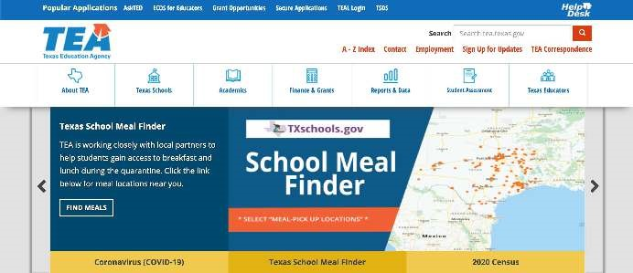
as
your
browser.
The state requires:
-
Payment of $
78
.00
for
I
ntern

C
certificate.
-
Payment of $
39
to

process
the criminal

background
check. Both are

payable to
SBEC by credit,

debit or
electronic check.
Also required:
-
Payment of $14.00 for
fingerprint service
.
Using Internet Explorer, go to
http://www.tea.texas.gov and click on “TEAL Login”.

TEAL Login
Put in the username and password you received by email from TEA. It is suggested that you copy and paste the password into the box. Click Login.
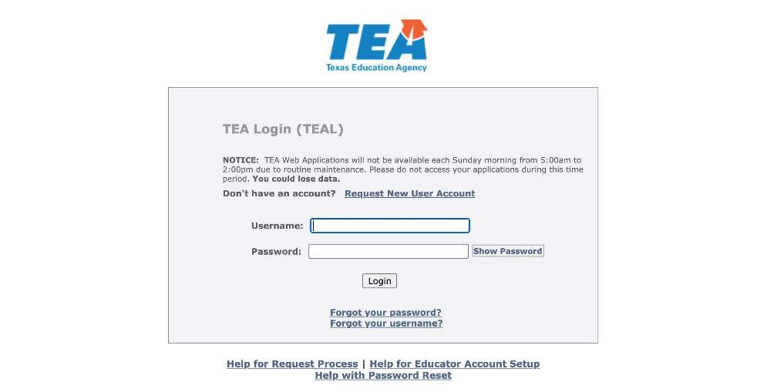

STEPS TO APPLY FOR INTERN CERTIFICATE
When you log in, always click on the underlined View My Educator Certification Account to access your educator profile. Make sure all profile information is always up to date.
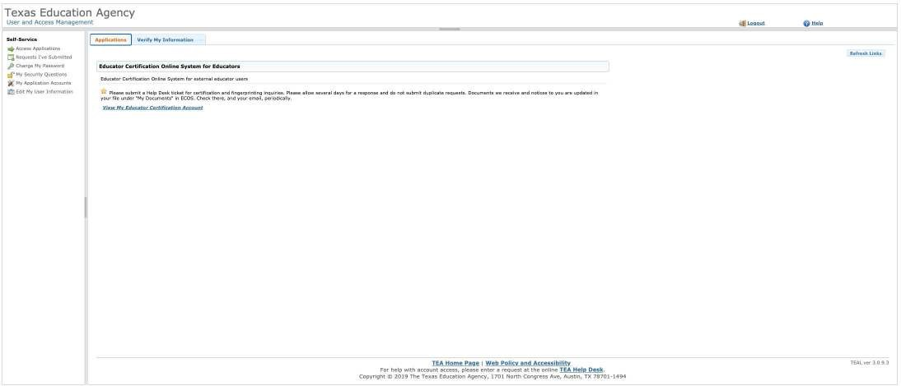
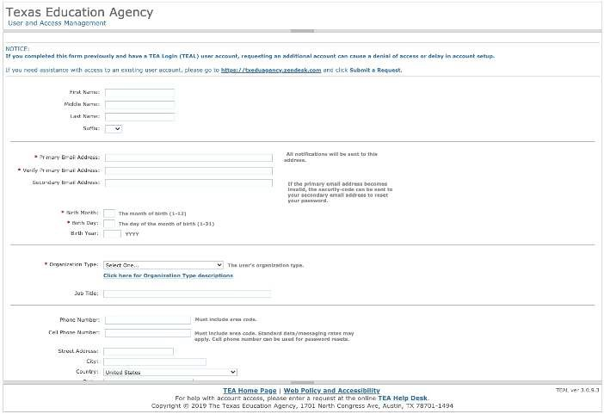
Create an account if you are a New User:
STEPS TO APPLY FOR INTERN CERTIFICATE
-Select “Request New User
Account”
-Select “Educator” in the Organization Type.
*Note: If you already have a TEA Profile Account, just log into your account. Review and update if needed. If you need assistance with access to an existing user account, please go to https:// txeduagency.zendesk.com
Fill in the information.
Select “Candidate participating in an Educator Preparation Program”.
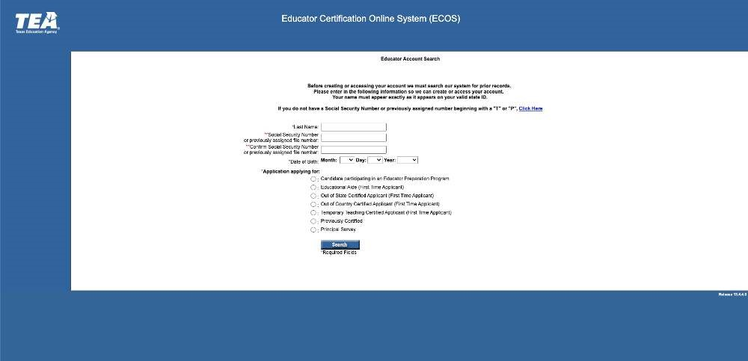
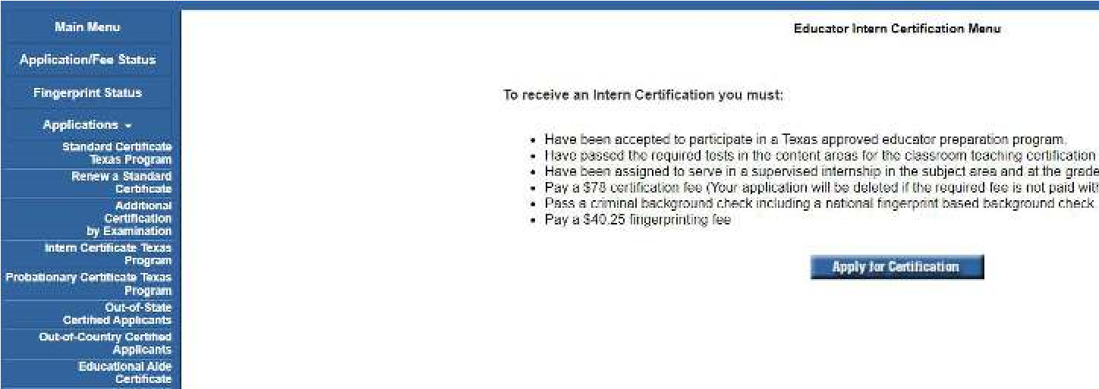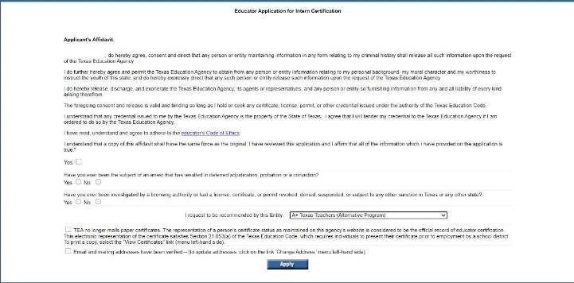
STEPS TO APPLY FOR INTERN
OR PROBATIONARY
CERTIFICATE
Click

the
“Applications”

button on left-
hand side of

screen,
then
click
on

“
Intern
Certificate Texas
Program”
or
"Probationary Certificate
Texas
Program."
D
o
NOT

select
“Temporary
Teacher

Cer
tificate.
”
Accurately complete the
affidavit.
Once you click on
"Apply for Certification," the
application will need to be
completed. Select
Houston
Community College

(
Alternative Program) as the
Entity:
Houston Community College
Note:
You
should
only select
"Probationary Certificate Texas
s
Program" if all Content and PPR
exa
ms have been passed and/or this
is a second
I
internship and all
qualifying exams have been passed.

Recommending Entity will be:
Houston Community College
It is very important that you select the correct Entity. Do NOT select any other Education Service Center Subject applying for is the certification area you are assigned to.
Click “Apply” and continue the prompts for payment. You will be prompted to pay the Intern Certificate application fee and the fingerprinting fees. Your application will be deleted if the required fee is not paid within 48 hours.

Please e-mail atcp@hccs.edu andl notify us once you have applied for your Intern Certificate, and then complete the fingerprinting process below. Once you accept a teaching job offer, be sure to submit your "Statement of Eligibility" form to the ATCP Inbox.
NOTE: If you pay for the Intern or Probationary Certificate, but do not get a position, or apply for the incorrect certificate all refund request for certificate fees shall be done through SBEC.
Fingerprinting fees are non-refundable.
STEPS TO APPLY FOR INTERN CERTIFICATE

FINGERPRINTS
- You will be prompted during the Intern Certification application process to pay the certificate application fee and pay the fingerprinting and national criminal history record check fee. Fingerprinting process is initiated once you apply and makes the payment for certification through the Educator Certification Online System (ECOS). When you pay for your certification, you will also be prompted to pay for the fingerprint background check. If you reside in Texas, you must submit fingerprints electronically, Option 1, using the Texas Department of Public Safety's (DPS) approved vendor, MorphoTrust/IdentoGO.
- Once payment is paid online, you will receive a confirmation email from IdentoGO containing your Unique Enrollment ID (UEID) and a hyperlink to schedule your fingerprinting appointment. Be sure to check your JUNK or SPAM folders just in case the TEA email went into those folders. If you do not pay the fee, you will NOT receive an email from IdentoGO. The email will be sent from the address nobody@uemail.identoGo.com.
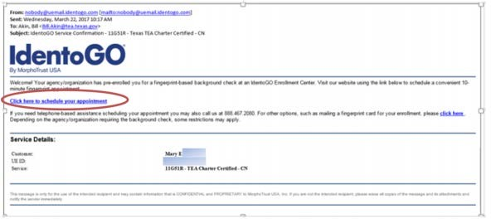
- To schedule a fingerprinting appointment, click on the hyperlink in the IdentoGO email, and proceed with appointment scheduling in the IdentoGO scheduling module. Please call MorphoTrust/ IdentoGO, 888-467-2080, with questions. Please note that, once pre-enrolled, you may also find the information necessary to schedule an appointment in your ECOS account.
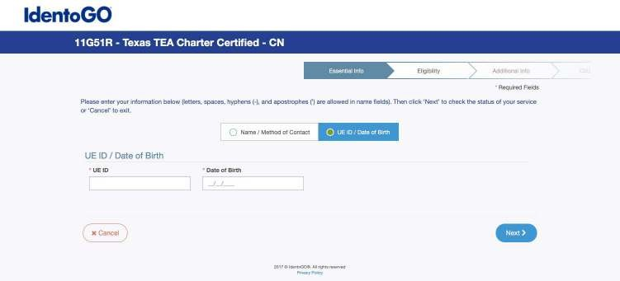

STEPS TO APPLY FOR INTERN CERTIFICATE
- After logging in, choose 'Fingerprint Status', and you will be taken to a screen that displays the UEID number, the service code and a link for appointment scheduling through MorphoTrust/
IdentoGo. The total fingerprinting background check fee in Texas is $50.25, $40.25 of which is paid in ECOS via credit card during the application process. An additional $10.00 is paid to MorphoTrust/ IdentoGo at the time of appointment scheduling. A valid photo ID is required at the time of the appointment. Texas Education Agency (TEA) fingerprinting results are received 5-7 business days after the fingerprint appointment.
- If you have questions about your Fingerprinting status, you may contact TEA at 512-936-8400 (Option 3 –Fingerprinting, OR email Fingerprinting Dept at http://www.tea.state.tx.us/index2.aspx? id=2147483982 You will need your TEA ID#, which is listed in your TEAL or ECOS account.
- Please e-mail atcp@hccs.edu once you have applied for your Intern Certificate. Once you accept a teaching job offer, be sure to submit your "Statement of Eligibility" form to the ATCP Inbox. Please note Fingerprinting fees are non-refundable.
- For additional information please refer to the TEA Help Desk HERE.
call TEA at |  | 512-936-8400, Option
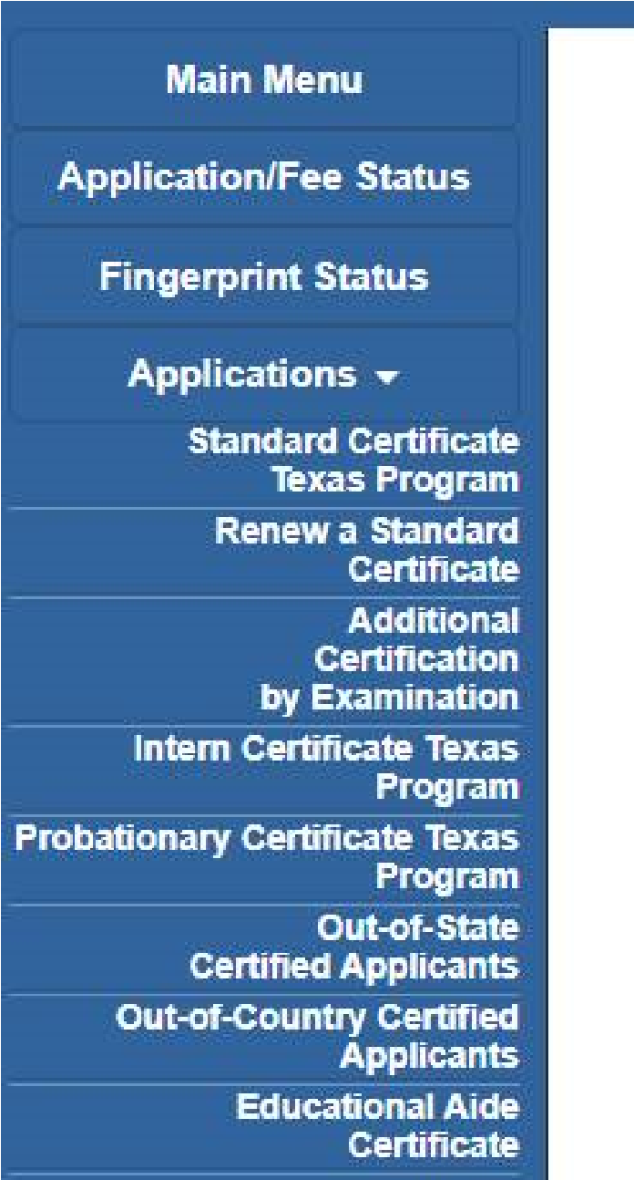
If you have been fingerprinted by
a school district and the district
has submitted your fingerprints
to TEA, you will need to contact
so that your prints can be
transferred. Once the request is
submitted the transfer should

need your TEA ID#. You may also
call TEA at 512-936-8400, Option
3 – Fingerprinting, but you could
be on hold for an extended time.
If your prints are not already on
file, you will need to complete the
fingerprinting process.

Field Supervision

Each candidate will be assigned a field supervisor that will provide feedback and support throughout the internship year. Field supervision is required by the TEA as a part of the internship process. The field supervisor’s responsibilities include, but are not limited to, conducting classroom observations, coaching candidates on best practices, and recommending professional development opportunities, classroom management techniques, and instructional strategies. The field supervision process is designed to align with the practices of teacher evaluations conducted by certified teacher appraisers (administrative supervisors at the candidate’s campus) as authorized by the TEA. Probationary Certificates and Intern Certificates require five observations. Field supervisors possess the discretion to require that a candidate have additional observations as required by the state from a field supervisor's observation of the candidate.

Field supervisors are assigned based upon candidate area of certification and candidate requirements. All field supervisors are assigned by ATCP leadership. Any changes to field supervision experience will need to be processed through the ATCP office and approved by ATCP leadership.

Testing

Before a candidate can register for any test, a candidate must have the approval from the ATCP office.

Candidates must successfully complete coursework and requirements in the following courses: ACP 4103, ACP 4201 & ACP 4113

Candidates must demonstrate proficiency at an 80% or better as measured by a TExES Representative Exam administered by the ATCP Program. Results of the Representative Exam will be issued to the candidate upon completion and next steps will be provided based on demonstration of content mastery.

Note: After 30 days, the exam release is subject to removal and proficiency requirements will need to be resubmitted for re-release.

Upon a passed or failed exam attempt, Educator Candidates must report their scores to the ATCP office via email atcp@hccs.edu for next steps.

2nd-5th Attempt- The candidate must complete and submit an "Exam Attempt Request Form" and schedule a Representative Exam per requested attempt and score an 80% or better in the content area(s) of focus. Candidates requiring above a 5th test attempt must complete a TEA request for a Test Limit Waiver (https://tea.texas.gov/texas-educators/certification/educator-testing/test-limit-waiver-information ).

All candidates must pass both the content and Pedagogy and Professional Responsibilities exams respectively prior to obtaining a Texas Standard Teacher Certificate:
  - Content Examination - based on certification area
  - Pedagogy and Professional Responsibilities (PPR) EC-12
  - Science of Teaching Reading - applicable based on certification area

TEA requires EPPs to properly prepare all candidates through required coursework and preparation prior to exam release. Upon a candidates demonstration of content mastery and program requirements one exam attempt for the requested area will be granted, per exam. All exam releases are subject to program requirements and approval. TEA allows for a maximum of five exam attempts.

Certifications Offered
Certificate(s) | Content Examinations | PPR Examinations
Core Subjects EC-6 | 0391 Core Subjects EC-6 (TExES) | 0160 PPR EC-12 (TExES)
Core Subjects 4-8 | 0211 Core Subjects 4-8 (TExES) | 0160 PPR EC-12  (TExES)
English Language Arts and Reading/Social  Studies 4-8 | 0113 English Language Arts and Reading/Social Studies 4-8 (TExES) | 0160 PPR EC-12 (TExES)
Mathematics 4-8 | 0115 Mathematics 4-8 (TExES) | 0160 PPR EC-12 (TExES)
Science 4-8 | 0116 Science 4-8 (TExES) | 0160 PPR EC-12 (TExES)
Social Studies 4-8 | 0118 Social Studies 4-8 (TExES) | 0160 PPR EC-12 (TExES)
English Language Arts and Reading 7-12 | 0231 English Language Arts and Reading (TExES) | 0160 PPR EC-12 (TExES)
Mathematics 7-12 | 0235 Mathematics 7-12 (TExES) | 0160 PPR EC-12  (TExES)
Life Sciences 7-12 | 0238 Life Science 7-12 (TExES) | 0160 PPR EC-12  (TExES)
Physical Science 6-12 | 0237 Physical Science (TExES) | 0160 PPR EC-12 (TExES)
Science 7-12 | 0236 Science 7-12 (TExES) | 0160 PPR EC-12 (TExES)
Physical Education EC-12 | 158 Physical Education EC-12 (TExES) | 0160 PPR EC-12 (TExES)
Special Education EC- 12 | 161 Special Education EC-12 (TExES) (Not standalone certificate) | 0160 PPR EC-12 (TExES)
Bilingual Education/Supplemental Spanish (attaches to level of base certificate) | 164 Bilingual Education (all level) | N/A (not standalone certificate)

Bilingual Education/Supplemental Spanish (attaches to level of base certificate) | 190 Bilingual Target Language Proficiency Test (BTLPT) - Spanish | N/A (not standalone certificate)
English as a Second Language (ESL) (attaches to level of base certificate) | 154 ESL Supplemental (TExES) | N/A (not standalone certificate)

NOTE: Content examinations, STR (if applicable), and supplemental exam (if applicable) must be passed to qualify for Intern Certificate. Content and PPR examinations must be passed to qualify for Probationary Certificate. TEA limits each candidate to a maximum of two Intern or Probationary certificate. Candidates exceeding the limit of certificates, will be required to obtain Clinical Teaching and released from ATCP. ATCP does not offer a Clinical Teaching component.

Section IV
Program Policies and Procedures

Policy for State Certification Testing
Educator candidates must receive permission to take any state certification examinations. Permission to grant any student to take any test state examinations is the discretion of the program (See page 19 for details).

Academic Standing
At the completion of each course cycle (e.g., eight-week course schedule), students will receive notification of their academic standing on the ATCP Checklist indicating their progress and academic standing.

Students in Good Standing
To determine candidates who meet the HCC system and the ATCP program requirements for the status of good standing see HCC Student Handbook and the glossary within the ATCP Student Handbook. Candidates in good standing also constitutes candidates classified as an active student. An active student or candidate is one that is presently enrolled in the program. An inactive student is one that has not enrolled in the program for two or more consecutive semesters which includes both the fall and spring semesters. Summer sessions are not included in this timeframe for consideration.

Students on Probation
Candidates may be placed on probationary status for failure to meet program requirements and maintain good academic standing. Candidates placed on probation will be notified of their status and will be required to correct any deficiencies by the end of each course cycle. Probation may be imposed for, but is not limited to, the following reasons:
- Excessive absences and tardiness in Alternative Teacher Certification Program classes. Failure to pass a course. Program staff will assign a mentor to a student who is struggling to pass course content. However, there is no guarantee that the assistance of a tutor will improve performance.
- Multiple failures (minimum three) to adhere to program policies and procedures
- Exhibition of behavior identified in Texas Administrative Code Chapter 247
- Improvement needed based on failed course work and/or the demonstration of poor performance as observed by program or district personnel.
- The need to repeat a year of internship due to poor performance.

Student (Educator Candidates) Dismissal
Candidates who habitually fail to meet the requirements to maintain good standing (see HCC Student Handbook and the ATCP Student Handbook for details), that continue to fail to complete program requirements, and/or failure to abide by the program’s policies and procedures following notification of probationary status in the ensuing course cycle may be subject to dismissal from the Program. The Program will work with the student to try to prevent this from occurring. Candidates may be subject to dismissal for the following reasons:
- Excessive absences and tardiness from Alternative Teacher Certification Program classes as attendance minimum are a State requirement (Students are urged to contact Program staff immediately if attendance will be an issue. Please know the College cannot change the State required minimum attendance; however, there may be options to consider.)
- Multiple failed courses (Program staff will assign a mentor to a student who is struggling to pass course content. However, there is no guarantee that the assistance of a tutor will improve performance.)
- Multiple failures (minimum three) adhering to program policies and procedures
- Multiple events (minimum three) where candidate has exhibited behavior identified in Texas Administrative Code Chapter 247.
- Multiple failures (minimum three) to correct deficiencies after the program and/or school district personnel request improvement
- Termination for cause from a position by the school district in which the candidate is a teacher of record
HCC policies - ATCP abides by the College’s policies as stipulated below:

1. Disciplinary Probation – A written reprimand for violation of specified regulations. Probation is for a designated period of time and includes the probability of more severe disciplinary sanctions including suspension or expulsion, if the student/organization is found to have engaged in additional violations during the probationary period. The Dean of Student Success/Designee may require a student to participate in activities that will enhance appropriate behavior(s) such as counseling, student conduct workshops, or alcohol and substance abuse workshops. Disciplinary Probation can be imposed for any length of time up to one calendar year and the student will be automatically removed from disciplinary probation when the imposed period expires.

2. Disciplinary Hold – A disciplinary hold will be placed on the student’s account preventing any transactions until the student has completed or satisfied all imposed disciplinary sanctions (i.e., transcript requests, registration, etc.,). This penalty is used in conjunction with other sanctions.

3. Disciplinary Suspension – Forced withdrawal from the College for either a definite period of time or until stated conditions have been met. Normally, suspension shall extend through a minimum of one regular long semester (with summer sessions not counting in the one semester minimum time lapse). However, suspension may exceed the one- semester minimum. This may include suspension of rights or privileges, including eligibility of official co-curricular activities with specific rights and/or privileges specified.

4. Disciplinary Expulsion – Permanent separation of the student/organization from the College. Administrative Withdrawal – Removal from an academic or non-credit bearing course as a result of disruptive or insubordinate behavior.

5. Educational Disciplinary Sanctions – Work assignments, Behavior Contracts, Essays, service to the College, or other related discretionary assignments. At their discretion, the Dean of Student Success/Designee, College President, or Student Conduct Administrator shall have the authority to require that a student/organization complete additional educational assignment, such as essays or research papers, attend meetings or training sessions, or perform services for the College.

6. Revocation of Admission and/or Degree/Certificate – The College shall have the authority to revoke a student’s admission or a degree or certificate for fraud, misrepresentation, violation of degree or certificate standards or other serious violations of conduct.

Transfers and Withdrawals
Candidates seeking to withdraw from a class must complete and submit the Program Adjustment Form (Add/ Drop form) found in the appendix to the program handbook and send via email to atcp@hccs.edu for processing. If a candidate fails to submit the Program Adjustment Form (Add/ Drop form) by the Division’s deadline for the add/drop period, a candidate may accrue a bill for the course. Candidates wishing to transfer or withdraw from the program must submit a written and signed request via email to atcp@hccs.edu for processing. Please include in this request your reason for transfer or withdrawal. Please allow up to 10-15 business days for processing. Transfers require the completion of the TEA Candidate Transfer Form. Candidates may not be enrolled in more than one educator preparation program at a time. The receiving educator preparation program decides whether or not to accept any or all of the previous coursework. If the student has outstanding financial issues with HCC, the College (or the program) will not provide any documentation until and unless those issues are resolved with the Business Office.

Pre-Intern and Intern Records
Pre-Intern and Intern records are maintained for a period of five (5) years after the individual completes, withdraws from, or is discharged from the program in compliance with State Board for Educator Certification (SBEC) requirements. All student records are maintained via governmental regulation and HCC has electronic student records from the College’s inception.

Changing Certification Area
Candidate requests for changing certification areas will be reviewed on a case- by- case basis based on individual surrounding circumstance. There will only be one allowable request for the duration of the candidate’s programing. Additionally course work and fees may apply.

Inactive Candidates Returning to Program

A candidate will be considered Inactive if they are absent from the program for more than 2 semesters. Candidates who are absent from the program for 2 semesters or more and want to return to the program will be subject to current program and state policies and standards.

Student Code of Conduct
Full Student Code of Conduct for HCC can be found at https://www.hccs.edu/about-hcc/procedures/student-rights-policies--procedures/
Board Policies: FLB(LOCAL); FM(LEGAL) Each student shall be charged with notice and knowledge of, and shall be required to comply with, the contents and provisions of the College’s policies, procedures, handbooks, rules and regulations concerning student conduct. All students shall obey the law, show respect for properly constituted authority, and observe correct standards of conduct. Each student shall be expected to:

- Demonstrate courtesy, even when others do not;
- Behave in a responsible manner, always exercising self-discipline;
- Attend all classes, regularly and on time; (stipulation that CE classes MUST have a minimum of 80% attendance or credit for the course cannot be conveyed)
- Prepare for each class and take appropriate materials and assignments to class;
- Obey all classroom rules;
- Respect the rights and privileges of students, faculty, and other College staff and volunteers;
- Respect the property of others, including College property and facilities; and
- Cooperate with and assist the College staff in maintaining safety, order, and discipline.

Section V
Student Services and System Policies

Student Services

Bookstore
Students may purchase textbooks, study aids, and a wide range of novelty items and apparel at the college bookstore. Students are encouraged to purchase books prior to the first day of class and can locate their course materials online at www.hccs.bncollege.com. Students should bring a copy of their class schedule to ensure that they are purchasing the correct texts. The bookstore will issue full refunds for textbooks during the first week of each term, provided the textbook is in original condition as when purchased and the original receipt is presented with request. For more information, visit www.hccs.bncollege.com. Students may also purchase their required texts at other retailers.

Parking Passes
Passes are available on-line annually after August 1st. Teacher candidates are only permitted to park in designated areas for students; all other parking zones are reserved for staff and faculty and any unauthorized vehicle will be towed at the vehicle owner's expense without warning.

HCC Policies
Here’s the link to the HCC Student Handbook https://www.hccs.edu/resources-for/current-students/student-handbook/ . In it you will find information about the following:

Academic Information | Incomplete Grades
Academic Support | International Student Services
Attendance, Repeating Courses, and Withdrawal | Health Awareness
Career Planning and Job Search | Libraries/Bookstore
Childcare | Police Services & Campus Safety
Ability Support Services | Student Life at HCC

Electronic Devices | Student Rights and Responsibilities
Equal Educational Opportunity | Student Services
Financial Aid TV (FATV) | Testing
General Student Complaints | Transfer Planning
Grade of FX | Veteran Services

EGLS3
The EGLS (Evaluation for Greater Learning Student Survey System) will be available for most courses near the end of the term until finals start. This brief survey will give invaluable information to your faculty about their teaching. Results are anonymous and will be available to faculty and division chairs after the end of the term. EGLS3 surveys are only available for the Fall and Spring semesters. EGLS3 surveys are not offered during the Summer semester due to logistical constraints.
http://www.hccs.edu/resources-for/current-students/egls3-evaluate-your-professors/

Campus Carry Link
Here’s the link to the HCC information about Campus Carry: http://www.hccs.edu/departments/police/campus-carry/

HCC Email Policy
When communicating via email, HCC requires students to communicate only through the HCC email system to protect your privacy. If you have not activated your HCC student email account, you can go to HCC Eagle ID and activate it now. You may also use Canvas Inbox to communicate. E mail communications received through other platforms may not be considered official so students are encouraged to use the HCC Eagle webmail to ensure communications are accepted as official.

Housing and Food Assistance for Students
Any student who faces challenges securing their foods or housing and believes this may affect their performance in the course is urged to contact the Dean of Students at their college for support. Furthermore, please notify the professor if you are comfortable in doing so. This will enable HCC to provide any resources that HCC may possess.

Office of Institutional Equity
Use the link below to access the HCC Office of Institutional Equity, Inclusion, and Engagement (http://www.hccs.edu/departments/institutional-equity/)

Ability Services
HCC strives to make all learning experiences as accessible as possible. If you anticipate or experience academic barriers based on your disability (including mental health, chronic or temporary medical conditions), please meet with a campus Abilities Counselor as soon as possible in order to establish reasonable accommodations. Reasonable accommodations are established through an interactive process between you, your instructor(s) and Ability Services. It is the policy and practice of HCC to create inclusive and accessible learning environments consistent with federal and state law. For more information, please go to https://www.hccs.edu/support-services/ability-services/

Title IX
Houston Community College is committed to cultivating an environment free from inappropriate conduct of a sexual or gender-based nature including sex discrimination, sexual assault, sexual harassment, and sexual violence. Sex discrimination includes all forms of sexual and gender-based misconduct and violates an individual’s fundamental rights and personal dignity. Title IX prohibits discrimination on the basis of sex-including pregnancy and parental status in educational programs and activities. If you require an accommodation due to pregnancy please contact an Abilities Services Counselor. The Director of EEO/Compliance is designated as the Title IX Coordinator and Section 504 Coordinator. All inquiries concerning HCC policies, compliance with applicable laws, statutes, and regulations (such as Title VI, Title IX, and Section 504), and complaints may be directed to:

David Cross, EdD Director EEO/Compliance
Office of Institutional Equity & Diversity 3100 Main
(713) 718-8271
Houston, TX 77266-7517 or Institutional.Equity@hccs.edu http://www.hccs.edu/departments/institutional-equity/title-ix-know-your-rights/

Office of the Dean of Students
Contact the office of the Dean of Students to seek assistance in determining the correct complaint procedure to follow or identify the appropriate academic dean or supervisor for informal resolution of complaints.
https://www.hccs.edu/about-hcc/procedures/student-rights-policies--procedures/student- complaints/speak-with-the-dean- of-students/

Veteran Services
The District Office of Veteran Affairs provides support to veterans and reservists, as well as to their families, who are eligible for education benefits under the Montgomery G.I. Bill, the Post 9/11 G.I. Bill, the Vocational Rehabilitation G.I. Bill, the Vocational Rehabilitation and Employment Program, and
The Hazelwood Act. The District Office of Veteran Affairs helps veterans and reservists apply for benefits, provide information, and serves as a liaison between the V.A. Regional Processing Office and college offices.

For more information: See Veteran’s Website at https://www.hccs.edu/support-services/veteran-affairs/

The Alternative Teacher Certification Program now receives the following eligible VA Benefits:
Chapter 33 (Post 9/11 GI Bill)
Chapter 30 (Active Duty)
Chapter 1606 (ARNG & Reserve)
Chapter 1607 (REAP)
Chapter 35 (Dependents)

For more information contact 713.718.8522 | vmassonline@hccs.edu

Career and Job Placement
Career & Job Placement Services’ offices are located at all main campuses as well as some satellite campuses. Career & Job Placement Services assists current and former HCC students with a variety of services including administering career assessments and providing placement services by connecting students with companies seeking talent for full or part-time employment jobs, as well as co-op/internship and externship opportunities. Career & Job Placement Services also assists students with developing career goals, resume writing, and interviewing, thus improving a student’s overall competitiveness and job readiness skills. Career & Job Placement Services connects students with their field(s) of interest by hosting professional development workshops with employers, as well as Industry-Focused Career Fairs throughout the year. HCC Career Fairs are held at all main campuses and some satellite locations. To find an HCC Career Center location at each of the six colleges, visit www.hccs.edu/support-services/career-planning/contact-career-centers.
Office Hours: Monday – Thursday: 8 a.m. - 6:30 p.m. Friday: 8 a.m. - 5 p.m. (by Scheduled Appointment) Drop-In Hours (Just Walk-In!): Monday – Thursday: 10 a.m. - 12 p.m., 2 p.m. - 4 p.m.

For more information, please visit: https://www.hccs.edu/support-services/career-planning/

HCC CareerHub
Students can interact with companies in their field of interest by using HCC’s job search tool, CareerHub, which transforms students’ career development experience in the following ways: • Download the CareerHub App to view or apply for jobs from a mobile phone; • Receive email or text notifications for jobs related to career interests; • Upload a resume to the CareerHub Resume Book for employers to view; • Apply for jobs in CareerHub and have a resume sent directly to the company; • Record a mock interview in CareerHub, and then send it to Career Services for feedback; and • Schedule resume writing and other appointments with any Career Center in the HCC System. Students can login to this new tool with their current MyEagle credentials at www.myeagle.hccs.edu.

Student Identification Card
Student identification (ID) cards are available once a student has registered and paid for classes. The card will be needed for library and computer lab usage, at offices providing student services, admission to college activities, and voting in campus elections. ID cards are non-transferable and are to be held only by the students to whom they were issued. Students are required to be in possession of their ID cards at all times. All ID cards are the property of HCC and must be shown when requested by a representative of the college district. If students lose their ID cards, they should report it to the police by calling 713.718.8888 as soon as it is discovered as missing. To obtain a replacement, initiate the process at the college campus you attend. A nominal fee will be charged for the replacement of lost ID cards.

Student picture ID cards are used to check out books and other materials from the library.
The home page also provides access to our extensive databases of magazines, professional journals, and newspaper articles. To access the periodical databases from a non-library computer you will need an HCC library barcode number which is located on the back of your student ID card. You may also obtain your barcode number by logging into the HCC Student System. Once you have signed in, navigate to the Personal Information section of the page, and then select Demographic Data. The HCC Library barcode number is located on the third line, underneath your student ID number.

For additional information, refer to www.hccs.edu/support-services/get-your-student-id/

Polices Services and Campus Safety
The HCC Police Department (HCCPD) is composed of sworn police officers, licensed by the State of Texas, and civilian security officers, all who are here to assist students and staff and provide a safe learning environment. HCCPD accepts all reports of criminal incidents occurring on campus, is responsible for campus law enforcement requirements, emergency response, and the investigation of any campus crime.

The department has a working relationship with the Houston Police Department, Harris County Sheriff Department, Fort Bend County Sheriff’s Department, and the Stafford Police Department to provide assistance with incidents that require special resources. HCCPD may investigate violations of the law or College rules and regulations. Administrative violations may be adjudicated in the HCC discipline process via the Student Code of Conduct. Violations which rise to violations of the law will/may be adjudicated by the appropriate court system. In the event of an Emergency on campus please call HCCPD at 713-718-8888 or dial 911. HCCPD provides the following services:

- Parking Passes – Parking passes are available online annually after August 1 and are required to be displayed on all cars parked on campus. More information about parking passes can be found in a student’s MyEagle account.
- Campus Escorts – HCCPD will provide a safety escort to all students, faculty, or staff upon request. Campus escorts may be scheduled by calling 713-718-8888.
- Vehicle Assists – Vehicle assistance is provided through a contractor for jump-starts, car unlocks, and other disabled vehicle situations on most college campuses. Officers will assist students in calling a service provider. PLEASE NOTE: All vehicle assist services must be paid for by the requester at the time the service is provided.
- Disabled Vehicles – Disabled vehicles may not remain on College property. To request assistance, call 713-718-8888.
- Lost and Found – HCCPD maintains the Lost and Found service. If a student finds an item on campus, it should be brought to 3821 Caroline Street or turned in to a police officer. HCCPD will hold found items for ninety days (with some exceptions of items being disposed of sooner). To recover lost items, call HCCPD at 713-718-8888 and an officer will be assigned to your inquiry.
- Crime Statistics – HCCPD also makes available information related to campus crime statistics. This information may be found by visiting: www.hccs.edu/departments/police/crime-statistics-- information.
- Safety Tips and Crime Prevention Information – Resources are available at www.hccs.edu/departments/police/crime-prevention--safety to include active shooter training, domestic violence information, general safety tips, and much more.
- To report that you have witnessed or been the victim of a crime, call HCCPD at 713-718-8888.

Additional Program & College Policies
Class Attendance
Students are expected to attend each session and complete any and all online classes. You are also responsible for materials covered during an absence. Instructors may be willing to consult with you for make-up assignments, but it is your responsibility to contact the instructor and make those arrangements-ideally in advance when possible. Class attendance is monitored. You may be dropped from a course for excessive absences (Per State regulation, students MUST attend 85% of any course. If more than 15% is missed, by regulation, the College and the Program cannot provide credit for that course and it would have to be repeated). Time is based on the start and end times of each class. In order to obtain certification, the program and the State require coursework and/or training hours to be met. Candidates must make every effort to contact their instructor when they are going to be tardy or miss a class. Medical excuses require a letter or statement from your doctor.

If attendance may present a problem, the student is encouraged to reach out to Program staff immediately to try to determine options available.

Religious Holidays
If students observe a religious holiday not part of the College’s instructional calendar and miss class, the student must notify the instructor in writing two weeks in advance to arrange to take a test or make up an assignment. A religious holiday is “a holy day observed by a specific religion and the place of worship is exempt from property taxation under Section 11.20 of the Tax Code.” Students are not expected to provide documentation of membership or adherence to specific religions and/or the practices.

Personal Property
Candidates are solely responsible for their personal property. The Alternative Teacher Certification Program and the College are not liable for loss or damage to the candidates’ personal property.

Eating and Drinking in Classrooms
Per College policy, no food, snacks, or drinks are permitted in the classrooms unless authorized by the instructor.

Dress Code
Candidates must abide by HCC dress code policy, but are expected to dress appropriately for face to face and virtual class.

Children
Children are not permitted in college classrooms or unattended on campus per College policy.

Smoking
HCC prohibits smoking inside any of its buildings, owned or leased, including offices, classrooms, restrooms, hallways, elevators, and all other interior locations. Smoking is permitted outside in approved areas established by each college, administrative, or support location.

Drug and Alcohol-Free Workplace
The Board strives to maintain a drug-and alcohol-free workplace environment. The College has adopted its Drug and Alcohol-Free Workplace Policy to further its objectives in establishing, promoting, and maintaining a safe, healthy, and productive work and learning environment for employees and students, to promote the reputation of HCC and its employees as responsible citizens of public trust, and to provide a consistent model of substance-free behavior for students.

Student Code of Conduct
Houston Community College views college-level students as adults who subscribe to a basic standard of conduct, which requires that they not violate any municipal, state or federal laws. Furthermore, no student may disrupt or otherwise interfere with any educational activity or fellow students’ right to pursue academic goals to the fullest in an atmosphere appropriate to a community of scholars. Any student failing to abide by appropriate standards of conduct during scheduled college activities may result in disciplinary action. Students suspected of violating the student code of conduct will be subject to the disciplinary process. Students have the right to due process.

Scholastic Dishonesty
Students are responsible for conducting themselves with honor and integrity in fulfilling course requirements. Penalties and/ or disciplinary proceedings may be initiated by college district officials against a student accused of scholastic dishonesty. “Scholastic Dishonesty” includes, but is not limited to, cheating on a test, plagiarism, and collusion. Possible punishments for academic dishonesty may include a grade of “0” or “F” on the assignment, failure in the course, and/or referral to the college Dean of Student Services for disciplinary action up to and including expulsion. Students have the right to appeal the decision.

Misuse of Electronic Devices in the Classroom
The use of electronic devices by students in the classroom is up to the discretion of the instructor. Any use of such devices for purposes other than student learning is strictly prohibited. If an instructor perceives such use as disruptive and/or inappropriate, the instructor has the right to terminate such use. If the behavior continues, the student may be subject to disciplinary action to include removal from the classroom or referral to the Dean of Student Services.

The Family Educational Rights & Privacy Act (FERPA)

Annual FERPA Notification
The Family Educational Rights and Privacy Act (FERPA) affords students in “attendance” at Houston Community College certain rights with respect to their education records. “Attendance”, as defined by Houston Community College, begins on the first day of the term in which a student is enrolled. These rights include:
- The right to inspect and review the student’s education records within 45 days of the day the College receives a request for access. A student should submit to the registrar a written request that identifies the record(s) the student wishes to inspect. The college official will make arrangements for access and notify the student of the time and place where the records may be inspected. If the records are not maintained by the college official to whom the request was submitted, that official shall advise the student of the correct official to whom the request should be addressed.
- The right to request the amendment of the student’s education records that the student believes are inaccurate, misleading, or otherwise in violation of the student’s privacy rights under FERPA. A student who wishes to ask the College to amend a record should write the College Official Responsible for the record, clearly identify the part of the record the student wants to be changed, and specify why it should be changed. If the College decides not to amend the record as requested, the College will notify the student in writing of the decision and the student’s right to a hearing regarding the request for amendment. Additional information regarding the hearing procedures will be provided to the student when notified of the right to a hearing.
- The right to provide written consent before the College discloses personally identifiable information from the student’s education records, except to the extent that FERPA authorizes disclosure without consent. The College may disclose education records without a student’s prior written consent under several FERPA exceptions including:
  - Disclosure to school officials with legitimate educational interests.
  - A school official is a person employed by the College in an administrative, supervisory, academic or research, or support staff position (including law enforcement unit personnel and health staff); a person or company with whom the College has contracted as its agent to provide a service instead of using College employees or officials (such as an attorney, auditor, or collection agent); a person serving on the Board of Trustees; or a student serving on an official committee, such as a disciplinary or grievance committee, or assisting another school official in performing his or her tasks.
  - A school official has a legitimate educational interest if the official needs to review an education record in order to fulfill his or her professional responsibilities for the College.
  - The student’s application for financial aid.
  - Submitting proof of dependency.
  - Response to a judicial order or subpoena.
  - A bona fide health or safety emergency.
  - Information requested by other schools in which the student seeks or intends to enroll.
  - As of January 2012, The U.S. Dept. of Education’s FERPA regulations expand the circumstances under which your education records and personally identifiable information (PII) contained in such records—including your SSN, grades, or other private information – may be accessed without your consent.
  - First, the U.S. Comptroller General, The U.S. Attorney General, the U.S. Secretary of Education, or state and local education authorities (“Federal and State Authorities”) may allow access to your records and PII without your consent to any third party designated by a Federal or State Authority to evaluate a federal or state-supported education program. The evaluation may relate to any program that is “principally engaged in the provision of education,” such as early childhood education and job training, as well as any program that is administered by an education agency or institution.
  - Second, Federal and State Authorities may allow access to your education records and PII without your consent to researchers performing certain types of studies, in certain cases even when we object or do not request such research. Federal and State Authorities must obtain certain use-restriction and data security promises from the entities that they authorize to receive your PII, but the Authorities need not maintain direct control over such entities.

- In addition, in connection with Statewide Longitudinal Data Systems, State Authorities may collect, compile, permanently retain, and share without your consent PII from your education records, and they may track your participation in education and other programs by linking such PII to other personal information about you that they obtain from other Federal or State data sources, including workforce development, unemployment insurance, child welfare, juvenile justice, military service, and migrant student records systems.
- The Family Educational Rights and Privacy Act (FERPA) of 1974, as amended, designates certain information related to a student as “Directory Information.” FERPA gives the College the right to disclose such information to anyone inquiring without having to ask a student for permission unless the student specifically requests in writing that all such information not be made public without written consent (Registration/Forms/confidentiality.pdf) except by the National Student Clearinghouse to loan guarantors. Houston Community College has designated the following as “Student Directory Information”:

- Student’s Name
- Address and telephone number
- Date of birth
- Major field of study
- Enrollment status (full/part-time)
- Classification
- Dates of attendance at HCC
- Number of semester hours completed & in progress
- Student classification
- Degrees earned and dates awarded
- Most recent previous educational institution attended

- The right to file a complaint with the U.S. Department of Education concerning alleged failures by the College to comply with the requirements of FERPA. The name and address of the Office that administers FERPA is:

Family Policy Compliance Office
U.S. Department of Education
400 Maryland Avenue, SW Washington, DC 20202-5901
ferpa@ed.gov

Refund Policy

The ATCP is part of the School of Continuing Education (SCE); as such, refund policies for SCE may be slightly different than for HCC. A full refund can only be awarded if a student withdraws before or on the first- class meeting date or if the class is canceled. There may be partial refunds, but this amount is not determined by the ATC program office. Please note that lack of attendance does not constitute a withdrawal or provide for any refund. Students must withdraw and request a refund from the SCE and the Houston Community College Southeast Business Office by the Official Enroll Date (OED) day or the third day of class. Any withdrawal after the OED day constitutes a charge for enrollment. The email to contact the HCC Southeast Business Office is sebusinesscashier@hccs.edu and the telephone number is 713-718-7051. The decision to reward a refund and the amount rewarded is determined by the Business Office and not the program. Thus, all refund request must go through the Business Office at the Houston Community College Southeast campus.

Notification of any withdrawal must be written and emailed to the ATC program at atcp@hccs.edu if a request is submitted.

Section VI
Financial Aid and Tuition & Fees

Financial Aid Assistance
Please see the Continuing Education Financial Aid Website for any available scholarships or grants approved for the Accelerated Teacher Certification Program.
Link: https://www.hccs.edu/applying-and-paying/financial-aid/continuing-education/

Individuals may qualify for the following:
- Workforce Innovation Opportunity Act (WIOA) - Workforce Solutions Scholarship (Up to total program cost)
  - Bilingual, Math, Science, and Special Education only
  - An Individual Referral/Cost Obligation Form will only be issued to students that have been admitted into the program. It is recommended students apply to Workforce Solutions' scholarship at least one month prior to the semester start date.
https://www.wrksolutions.com/find-a-location

ESTIMATED TOTAL PROGRAM COST | ESTIMATED HCC PROGRAM COST
ATCP Estimated Tuition  (Based on a total of 10 courses) | $ 4,220
ATCP Application Fee | $ 75
ESTIMATED TOTAL COST | $ 4,295

Program Glossary
Academic year: If not referring to the academic year of a particular public, private, or charter school or institution of higher education, September 1 through August 31.

Active Students (Candidates): An active student or candidate is one that is presently enrolled in the program.

Alternative Certification Program: An approved educator preparation program, delivered by entities specifically designed as an alternative to a traditional undergraduate certification program, for individuals already holding at least a bachelor's degree.

Candidate: An individual who has been admitted into an educator preparation program, including an individual who has been accepted on a contingency basis; also referred to as an enrollee or participant.

Clock-Hours: The actual number of hours of coursework or training provided; for purposes of calculating the training and coursework required, one semester credit hour at an accredited university is equivalent to 15 clock-hours. Clock-hours of field-based experiences, clinical teaching, internship, and practicum are actual hours spent in the required educational activities and experiences.

Completer Agreement: An opportunity which allows for additional support, training, and assistance. It allows for the candidate to complete outstanding program requirements and/or additional training and/ or to meet program requirements. Additional program fees may apply.

Dismissal: Dismissal will occur in the event a candidate:
- Is terminated from a position under district board policy
- Falsifies information or documents including plagiarism
- Fails to comply with training requirements
- Upon the advice of legal counsel for cause
- A student may be removed from the program during the internship for failure to fulfill the roles and responsibilities of a classroom teacher and/or meet program expectations.

Educator preparation program (EPP): An entity that must be approved by the State Board for Educator Certification to recommend candidates in one or more educator certification fields.

Entity: The legal entity that is approved to deliver an educator preparation program.

Field Supervisor: A certified educator, hired by the educator preparation program, who preferably has advanced credentials, to observe candidates, monitor their performance, and provide constructive feedback to improve their effectiveness as educators.

Field-Based Experience: Introductory experiences for a certification candidate involving reflective observation of Early Childhood-Grade 12 students, teachers, and faculty/staff members engaging in educational activities in a school setting. Field-based experiences must include 15 clock-hours in which the candidate, under supervision, is actively engaged in instructional or educational activities that include authentic school settings in a public school accredited by the TEA or other school approved by the TEA for this purpose:

- Instruction by content certified teachers;
- Actual students in classrooms/instructional settings with identity-proof provisions
- Content or grade-level specific classrooms/instructional settings; and
- Reflection of the observation

Good Standing: Candidates who continue to be successful and complete program requirements. Among them are:
- Completing coursework as scheduled.
- Not on academic probation or suspension
- Maintaining a GPA of 2.0 or greater.
- Attending class(es) as scheduled.
- See also HCC Student Handbook for definition.

Inactive Students (Candidates): A student or candidate who has not enrolled for two or more consecutive regular semesters (fall, spring) will automatically be placed in an inactive status.

Internship: A supervised, full-time educator assignment for one full school year at a public school accredited by the Texas Education Agency (TEA) or other school approved by the TEA for this purpose that may lead to the completion of a standard certificate.

Internship Certificate: A type of certificate as specified in §230.36 of this title (relating to Intern Certificates) that is issued to a candidate who has passed all required content pedagogy certification examinations and is completing initial requirements for certification through an approved educator preparation program.

Late Hire: An individual who has not been accepted into an educator preparation program before the 45th day before the first day of instruction and who is hired for a teaching assignment by a school after the 45th day before the first day of instruction or after the school's academic year has begun.

Mentor: For a classroom teacher, a certified educator assigned by the campus administrator who has completed mentor training; who guides, assists, and supports the teacher during his or her intern year in areas such as planning, classroom management, instruction, assessment, working with parents, obtaining materials, district policies; and who reports the teacher's progress to that teacher's educator preparation program.

Pedagogy: The art and science of teaching, incorporating instructional methods that are developed from scientifically-based research.

Plagiarism: Plagiarism is defined as the appropriation of another's work and the unacknowledged incorporation of that work in one's own written work offered for credit. Plagiarism violates HCC’s Student Code of Conduct and can be grounds for dismissal from the College.

Probation: An infraction of any of the training requirements or other specifications detailed in the Student/Intern Handbook will result in a student being placed on probation. Probation may be imposed for, but not limited to the following reasons:
- Failure to submit documents in a timely manner (minimum 3 offenses)
- Failure to make-up assignments from missed classes (minimum 3 offenses)
- Exhibition of behavior identified in Texas Administrative Code Chapter 247
- Program or district request for improvement based on poor classroom or coursework performance

Probationary Certificate: Probationary certificate--A type of certificate as specified in §230.37 of this title (relating to Probationary Certificates) that is issued to a candidate who has passed all required certification examinations and is completing requirements for certification through an approved educator preparation program.

Statement of Eligibility (SOE): A document that informs a hiring district that a candidate is eligible for hire. An audit must be conducted to verify that the candidate has satisfactorily completed required course work and tests including content/supplemental exams. An internship is not considered active until an SOE has been issued and returned completed by the hiring district.

Statute of Limitations (SOL): The statute of limitations date or the SOL date prescribes a time limit for completion of program requirements. Extensions must be approved by the Program and be in line with State expectations.

Student: An enrolled candidate, or participant that has been admitted into an educator preparation program seeking certification.

Teacher of Record: An educator employed by a school district who teaches the majority of the instructional day in an academic instructional setting and is responsible for evaluating student achievement and assigning grades.

Texas Essential Knowledge and Skills (TEKS): The Kindergarten-Grade 12 state curriculum in Texas adopted by the State Board of Education and used as the foundation of all state certification examinations.

Policies and Procedures Acknowledgement Form
My signature affirms that I accept the policies and procedures delineated in the program handbook for the HCC Alternative Teacher Certification Program. I affirm that I have read the information in the program handbook, and I agree to adhere to all the program and policies, procedures, and requirements.

Printed Name

Signature

Date

HCC ATCP Standard Teacher Certificate Candidate Checklist

Clear Form PROGRAM ADJUSTMENT FORM DATE ENTERED

STUDENT ID (9 digit) NAME TODAY'S DATE

TERM: (CHECK ONE)
□ FALL D SPRING D SUMMER I
Students who enroll in a class for a third time will be charged additional tuition and fee charges.

YEAR

CLASS NUMBER

DROPS
PREFFIX & COURSE

INSTRUCTOR

ACTION

REASON FOR CHANGE

OFFICE USE ONLY

EFFECTIVE DATE

%REFUND
No Refund

CLASS NUMBER

ADDS
PREFFIX & COURSE

INSTRUCTOR
Signature Field

COMMENTS

Student Signature Student Phone Number
With few exceptions, state law gives you the right to request, receive, review and correct information about yourself collected on this form.

College Official/Instructor Campus

FORM REV. 12/11

Directions: Complete this form (including signature of teacher observed) after completing all thirty hours of observation and then answer each question in the space provided. The thirty hours of observation must be with the same teacher. Submit the completed form to your ATCP 2000 instructor when complete. A reflective observation serves as an introductory experience involving the observation of the instruction of a certified teacher providing instruction in a classroom setting.

STUDENT INFORMATION
Name of Applicant: |  | Processing Date:
Telephone Number: |  | Student ID:
ADMISSIONS INFORMATION:
School District Name: |  | School Name:
Type of school: | - Public ☐Charter ☐Private ☐Parochial ☐Montessori ☐ Other:
Grade level observed: | ☐ Pre-K ☐ Kindergarten ☐1 ☐2 ☐3 ☐4 ☐5 ☐6 ☐7 ☐8 ☐9 ☐10 ☐11 ☐12
Subject Observed: |  | Date(s) Observed:
Teacher Observed: |  | Teacher Signature:

1. What were the students expected to know (objectives) upon completion of the lesson? | 2. Briefly describe what the teacher did during the lesson.
3. Briefly describe how the students were involved in the lesson. | 4. What materials were used (i.e. worksheets, maps, audio/visuals, chalkboard etc...)?
5. Describe a student's behavior problem and the strategies used to change the behavior. If no off-task behavior was observed, how did the teacher achieve classroom management? | 6. What did you like about the lesson?
7. What would you do to enhance the lesson or what would you have done differently? | 8. Was the objective of the lesson met? Explain

Directions: The thirty-hour field-based observation serves as an introductory experience involving the observation of the instruction of a certified teacher providing instruction in a classroom setting. This task is required for the Texas standard teacher certification. Complete this form (including signature of teacher observed). Observation hours should be in-person, but fifteen hours of field-based observation can be virtual. Observations should also be with the same teacher. Submit the completed form to your ATCP 2000 instructor to receive credit for this state requirement.

STUDENT INFORMATION
Name of Applicant: |  |  | Processing Date:
Telephone Number: |  |  | Student ID:
ADMISSIONS INFORMATION:
School District Name: |  |  | School Name:
Type of school: | - Public ☐Charter ☐Private ☐Parochial ☐Montessori ☐ Other:
Grade level observed: | ☐ Pre-K ☐ Kindergarten ☐1 ☐2 ☐3 ☐4 ☐5 ☐6 ☐7 ☐8 ☐9 ☐10 ☐11 ☐12
Subject Observed: |  |  | Date(s) Observed:
Teacher Observed: |  |  | Teacher Signature:
Observation Description |  | Observation Type |  | Completion Date |  | Hours Observed
 |  | N/A
 |  | N/A
 |  | N/A
 |  | Active
 |  | N/A
 |  | N/A
 |  | N/A
 |  | N/A
 |  | N/A
 |  | N/A
 |  | N/A
 |  | N/A
 |  | N/A
 |  | N/A
Total Field-based Hours Observed |  |  |  |  |  | 0

EDUCATOR’S CODE OF ETHICS

Student (Print Name): ____________________________

Instructions: Per 19 TAC § 228.50: Each EPP student signs a document acknowledging their understanding and agreement to adhere to the Educators’ Code of Ethics. Please read and sign on the last page. Each EPP student will read, acknowledge, and sign the educator’s code of ethics. Should you have questions about this document, please contact the Program Director.

Texas Administrative Code
TITLE 19 EDUCATION
PART 7 STATE BOARD FOR EDUCATOR CERTIFICATION
CHAPTER 247 EDUCATORS' CODE OF ETHICS
RULE §247.2 Code of Ethics and Standard Practices for Texas Educators

Enforceable Standards.

(1) Professional Ethical Conduct, Practices and Performance.

- Standard 1.1. The educator shall not intentionally, knowingly, or recklessly engage in deceptive practices regarding official policies of the school district, educational institution, educator preparation program, the Texas Education Agency, or the State Board for Educator Certification (SBEC) and its certification process.

- Standard 1.2. The educator shall not intentionally, knowingly, or recklessly misappropriate, divert, or use monies, personnel, property, or equipment committed to his or her charge for personal gain or advantage.

- Standard 1.3. The educator shall not submit fraudulent requests for reimbursement, expenses, or pay.

- Standard 1.4. The educator shall not use institutional or professional privileges for personal or partisan advantage.

- Standard 1.5. The educator shall neither accept nor offer gratuities, gifts, or
favors that impair professional judgment or that are used to obtain special advantage. This standard shall not restrict the acceptance of gifts or tokens offered and accepted openly from students, parents of students, or other persons or organizations in recognition or appreciation of service.
- Standard 1.6. The educator shall not falsify records, or direct or coerce others to do so.
- Standard 1.7. The educator shall comply with state regulations, written local school board policies, and other state and federal laws.
- Standard 1.8. The educator shall apply for, accept, offer, or assign a position or a responsibility on the basis of professional qualifications.
- Standard 1.9. The educator shall not make threats of violence against school district employees, school board members, students, or parents of students.
- Standard 1.10. The educator shall be of good moral character and be worthy to instruct or supervise the youth of this state.
- Standard 1.11. The educator shall not intentionally, knowingly, or recklessly misrepresent his or her employment history, criminal history, and/or disciplinary record when applying for subsequent employment.
- Standard 1.12. The educator shall refrain from the illegal use, abuse, or distribution of controlled substances, prescription drugs, and toxic inhalants.
- Standard 1.13. The educator shall not be under the influence of alcohol or consume alcoholic beverages on school property or during school activities when students are present.
(2) Ethical Conduct toward Professional Colleagues.
- Standard 2.1. The educator shall not reveal confidential health or personnel information concerning colleagues unless disclosure serves lawful professional purposes or is required by law.
- Standard 2.2. The educator shall not harm others by knowingly making

false statements about a colleague or the school system.
- Standard 2.3. The educator shall adhere to written local school board policies and state and federal laws regarding the hiring, evaluation, and dismissal of personnel.
- Standard 2.4. The educator shall not interfere with a colleague's exercise of political, professional, or citizenship rights and responsibilities.

- Standard 2.5. The educator shall not discriminate against or coerce a colleague on the basis of race, color, religion, national origin, age, gender, disability, family status, or sexual orientation.
- Standard 2.6. The educator shall not use coercive means or promise of special treatment in order to influence professional decisions or colleagues.
- Standard 2.7. The educator shall not retaliate against any individual who has filed a complaint with the SBEC or who provides information for a disciplinary investigation or proceeding under this chapter.
- Standard 2.8. The educator shall not intentionally or knowingly subject a colleague to sexual harassment.
(3) Ethical Conduct toward Students.
- Standard 3.1. The educator shall not reveal confidential information concerning students unless disclosure serves lawful professional purposes or is required by law.
- Standard 3.2. The educator shall not intentionally, knowingly, or recklessly treat a student or minor in a manner that adversely affects or endangers the learning, physical health, mental health, or safety of the student or minor.
- Standard 3.3. The educator shall not intentionally, knowingly, or recklessly misrepresent facts regarding a student.
- Standard 3.4. The educator shall not exclude a student from participation in a program, deny benefits to a student, or grant an advantage to a student on the basis of race, color, gender, disability, national origin, religion, family status, or

sexual orientation.
- Standard 3.5. The educator shall not intentionally, knowingly, or recklessly engage in physical mistreatment, neglect, or abuse of a student or minor.
- Standard 3.6. The educator shall not solicit or engage in sexual conduct or a romantic relationship with a student or minor.
- Standard 3.7. The educator shall not furnish alcohol or illegal/unauthorized drugs to any person under 21 years of age unless the educator is a parent or guardian of that child or knowingly allow any person under 21 years of age unless the educator is a parent or guardian of that child to consume alcohol or illegal/unauthorized drugs in the presence of the educator.
- Standard 3.8. The educator shall maintain appropriate professional educator-student relationships and boundaries based on a reasonably prudent educator standard.
- Standard 3.9. The educator shall refrain from inappropriate communication with a student or minor, including, but not limited to, electronic communication such as cell phone, text messaging, email, instant messaging, blogging, or other social network communication. Factors that may be considered in assessing whether the communication is inappropriate include, but are not limited to:
- the nature, purpose, timing, and amount of the communication;
- the subject matter of the communication;
- whether the communication was made openly, or the educator attempted to conceal the communication;
- whether the communication could be reasonably interpreted as soliciting sexual contact or a romantic relationship;

- whether the communication was sexually explicit; and
- whether the communication involved discussion(s) of the physical or sexual attractiveness or the sexual history, activities, preferences, or fantasies of either the educator or the student.

EDUCATOR’S CODE OF ETHICS
Please print, sign, and date below. Your signature below acknowledges the requirement and understands & agrees to adhere to the Educator’s Code of Ethics.

Print Name Signature Date

